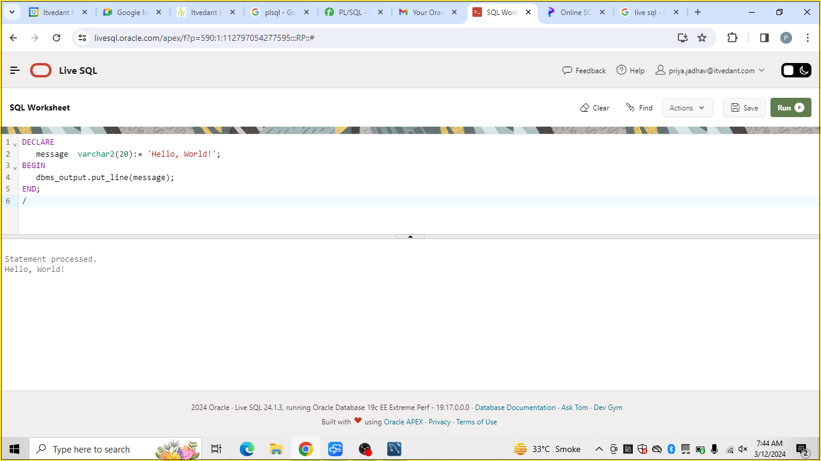

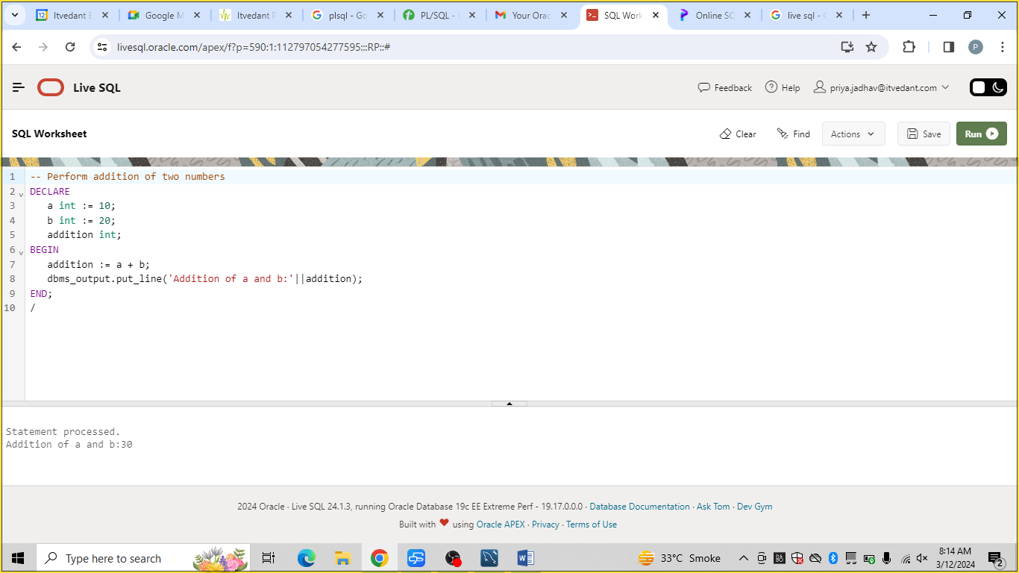

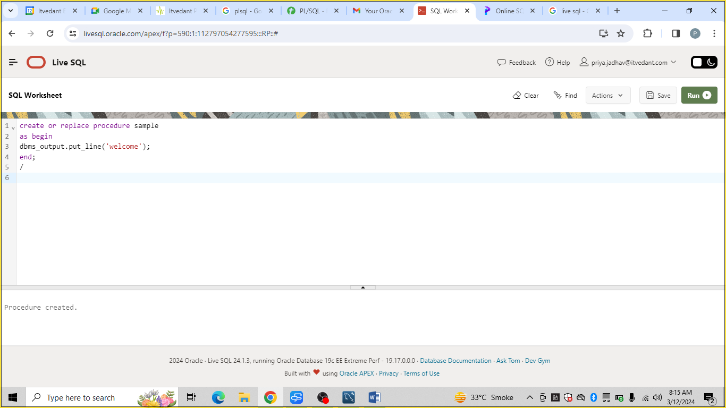

create or replace procedure sample

as begin

dbms_output.put_line('welcome');

end;

/

begin

sample;

end;

/

exec sample;

execute sample;

call sample;

-------------------------------------

create or replace procedure sample(iname char)

as begin

dbms_output.put_line('welcome '||iname);

end;

/

exec sample('raj');